Otago Polytechnic

# YEar Three Special Topic

ID730151 Year Three Special Topic

Evan (Honghao) Huang

Student ID number 1000090458

Email: huanh8@student.op.ac.nz

**Contents**

Networking - mutiplayer 1 3

Networking - mutiplayer 2 ……………………………………………………..………… …… 9

Checkerboard …………………………………………………..………… .…… 13

Checkerboard Pieces 1 …………………………………………………..………… …… 23

Week 5 ABILITY PARTICLES 4 …………………………………………………………….. …… 27

Week 6 ABILITY PARTICLES 5 …………………………………………………..……… ……… 00

Week 7 ABILITY PARTICLES 6 ……………………………………………………..……… ……… 00

Week 8 ABILITY PARTICLES 7 ……………………………………………………..……… ……… 00

Week 9 ABILITY PARTICLES 8 ……………………………………………………..…… ………… 00

Week 10 ABILITY PARTICLES 9 ……………………………………………………..…… ………… 00

Week 11 ABILITY PARTICLES 10 …………………………………………………..…… ………… 00

Week 12 ABILITY PARTICLES 11………………………………………………..…… ………… 00

Week 13 ABILITY PARTICLES 4 …………………………………………… …..……………… 00

Week 14 ABILITY PARTICLES 4 ………………………………………………..……… ……… 00

Week 15 ABILITY PARTICLES 4 ………………………………………………..………… …… 00

Week 16 ABILITY PARTICLES 4 ………………………………………………..………… …… 00

## Muitiplayer – networking 1

First of all, we need to set up by install these dependencies

### Environment and Player

Create a basic environment which is just a plane and a player who is a capsule for now.

We need a network manager as a controller.

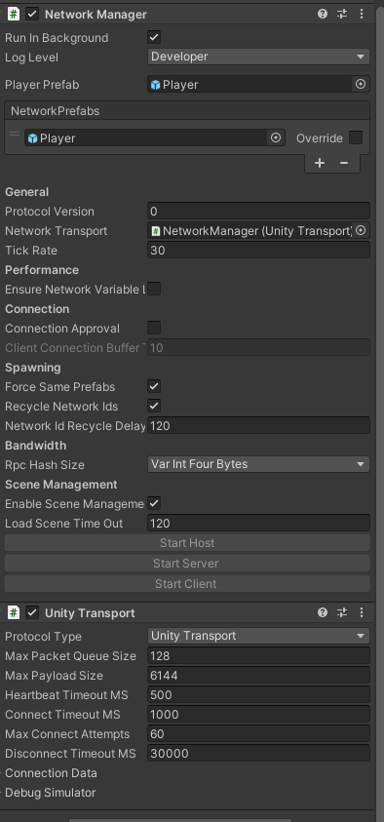Attach NetworkManager component and fill the player refab into the NetworkPrefabs slot.Therefore,we are able to pass the data to the network.

Attach Unity Transsport component

Set the protocol type to be Unity transport.So we can access the unity transport through the network.



Attach a player network script to it and add a basic movement function for testing.

Also, we need to attach Network object component to it.

Client Network Transform component for passing data. In this case we only need to pass position x and z to move around the player

### UI

Set up three buttons for controller.

Add a basic callback function for these three buttons.

### Testing

Build this project and create a host on it, while create client on unity editor, and we are able to move and they are synchronized .

## MUITIPLAYER – NETWORKING 1

### Passing data

The PlayerNetwork should inheritance from NetworkBehaviour

Create MyCustomDatafor data passing, and also we need to serialize it, otherwise it won’t work.

Using NetworkVariable function to create a randomNumber base on MyCustomData.

Set the NetworkVariableReadPermission to Everyone,

Saet the NetworkVariableWritePermission only for owner.

Createa Interact function by press T key on the keyboard.

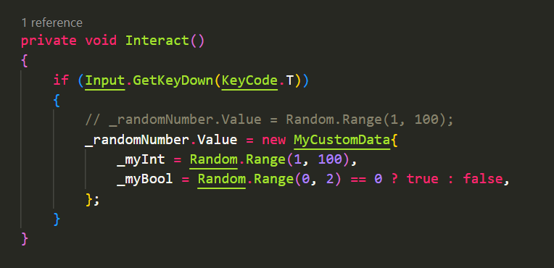Then create a new random number.

Subscript OnRandomNumberChanged to OnNetworkSpawn.

It allows us to change the data on the network.

if (!IsOwner) return;

This is allowed that only owner can control itself otherwise both host and client will move at the same time and position.

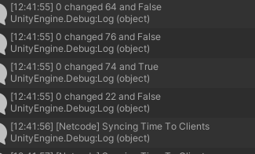Build again, press T key on the client end we can see the data on the console log on the Host end.

## Checkerboard

Create a board game object on the scene.

Iterate the loop to create quad in each row.

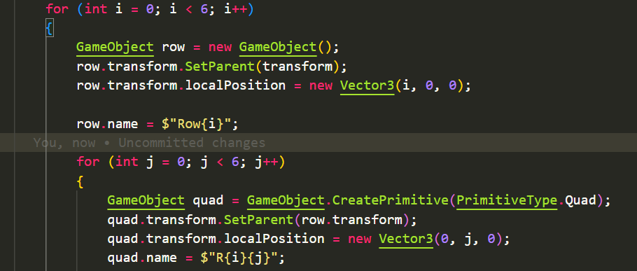

Change each color on the quad

Rotate the board and generate it.

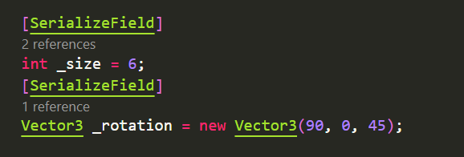



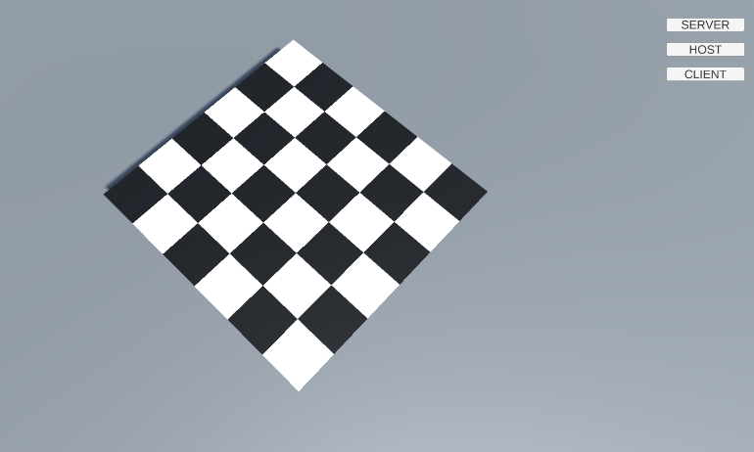

## Checkerboard-Pieces 1

Create a 2d array and set the size to 6 and declare piece prefabs





We only need 6 pieces for each player and initially place them at the correct place by a calculation.

Also, each piece will be attached to each quad for now.

